Centurion

Process Optimization Software
User Manual

Table of Contents

1. Overview 3
2. Definitions 3
3. How to use Autoset 4
3.1. Open Autoset function 4
3.2. Recipe settings 5
3.3. PCB settings 7
3.4. Run Autoset 8
3.5. Save recipe 9
3.6. Test and edit the new recipe 9
4. Frequently asked questions 9

- Overview
Autoset is a user-friendly optimization application that is now included in the Vitronics Soltec Centurion oven control software. Autoset will drastically cut down the time needed to determine the appropriate individual heater temperature and conveyor speed that are necessary to successfully process a circuit board according to a particular solder paster supplier thermal requirements. The guess work has been removed so that a setup technician can have an effective starting point when designing a recipe to meet production needs while avoiding conventional oven setup pit falls. Autoset is simple, fast and easy to use, and requires minimal technical experience.

Autoset has been integrated into the recipe management function of the Centurion software. It can be used to generate new recipes. The setup technician opens the Autoset function in the recipe management and enters the recipe group, recipe name and select a paste profile. Next enters the board dimensions and weight. The paste profile is also called Process Window, which contains the range of necessary temperatures, supplied by the paste manufacturer, needed to properly process the paste. The Process Window can be edited to consider the thermal limitations of certain board components. The thermal requirements from the paste manufacturer and the values entered for the board dimensions and weight, are used by the Autoset algorithm to optimize the set point values for all the heaters and the conveyor speed. The algorithm also produces a statistical ranking known as the Process Window Index (PWI).

It must be understood that Autoset will not recommend settings for fan speed, cooling temperature, atmosphere type or oxygen concentration. These paremeters must be manually set within the recipe if they are included in options of the Centurion oven. Remember also that a change in fan speed will directly affect the transfer of heat and alter the performance of a recipe.

Before the recipes generated by Autoset are used in production, it should be tested. It can then be manually adjusted to more closerly meet your production requirements if necessary. A verification profile should always be run after any changes have been made to a recipe.

- Definitions
Recipe
A function in the Centurion software that contains all of the setpoints for all the standard and optional features of the Centurion oven. The recipe can be saved under a descriptive name and can also contain text that is written to explain its intended use. Recipes are saved as files, organized into folders and can be shared between ovens. Some common recipe setpoints are heat zone temperature, conveyor speed, cooling temperature and lane width.
Setpoint
Setpoint is the target value that an automatic control system is trying to attain. It is the desired result.
Profile
A profile is the result of a process that measures and records the temperature gradients on a test board of a given mass as it travels through a reflow oven at a given speed. The resulting graphical profile characterizes how effectively the reflow oven heats and cools the test board as it travels at a given speed. The resulting information can be used to verify the effectiveness of a recipe or be used by prediction software (Autoset) to determine appropriate temperature and speed setpoints.
Ramp soak spike
A method of applying heat to a circuit board characterized by a steady increase to a certain temperature at which point it levels off to a large degree before again increasing to the reflow temperature. The intention is to give the assembly time to reach equilibrium across the board before the final increase to reflow temperature.
Straight ramp
A method of applying heat to a circuit board characterized by a linear increase in heat to reflow temperature.
Process Window
This is a function of Autoset that contains all of the thermal requirements needed by a certain solder paste to work successfully. All of the requirements combined as a matrix to create a “window” within which the process must remain or the board will be compromised. The thermal parameters can be edited to accommodate the thermal sensitivity of certain board components.
Process Window Index
The PWI is a number that describes how the newly generated recipe is expected to process a board within the tolerances of the paste manufacturer’s thermal requirements for the selected paste. A PWI of 0 is optimal. This means that the recipe should produce a result strictly in accordance with the paste’s heating requirements. A PWI of 100 means that the recipe will produce results that are acceptable but are at the outer limits of the provided tolerances. A PWI of any greater than 100 means the recipe will not produce thermal results within the tolerances. The lower the PWI value the more drift in the temperatures can be tolerated and still produce good product.
Algorithm
A set of ordered steps for solving a problem, such as a mathematical formula or the instuctions in a computer program such as Autoset.

- How to use Autoset
  - Open Autoset function

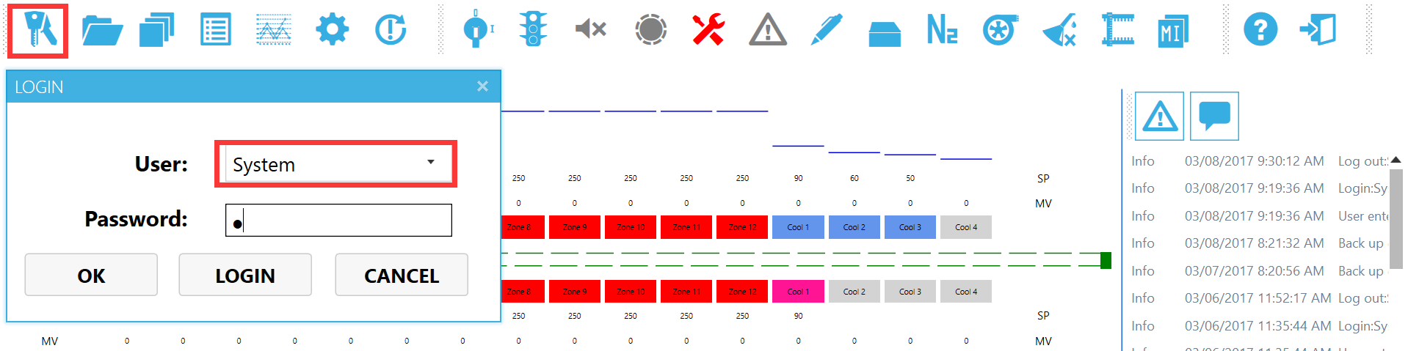

Logon to the Centurion software as user “System”, then click the icon “Recipe manager”.

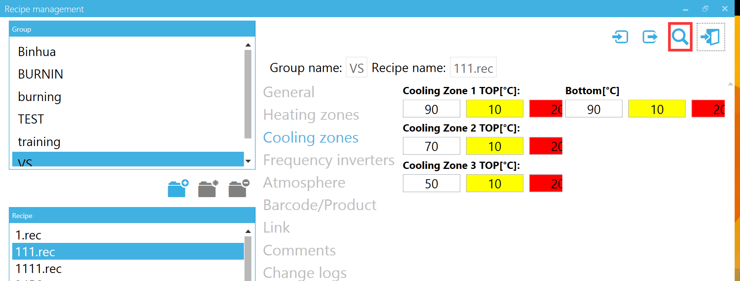

Click the icon “Autoset”, the Autoset screen will appear.

  - Recipe settings

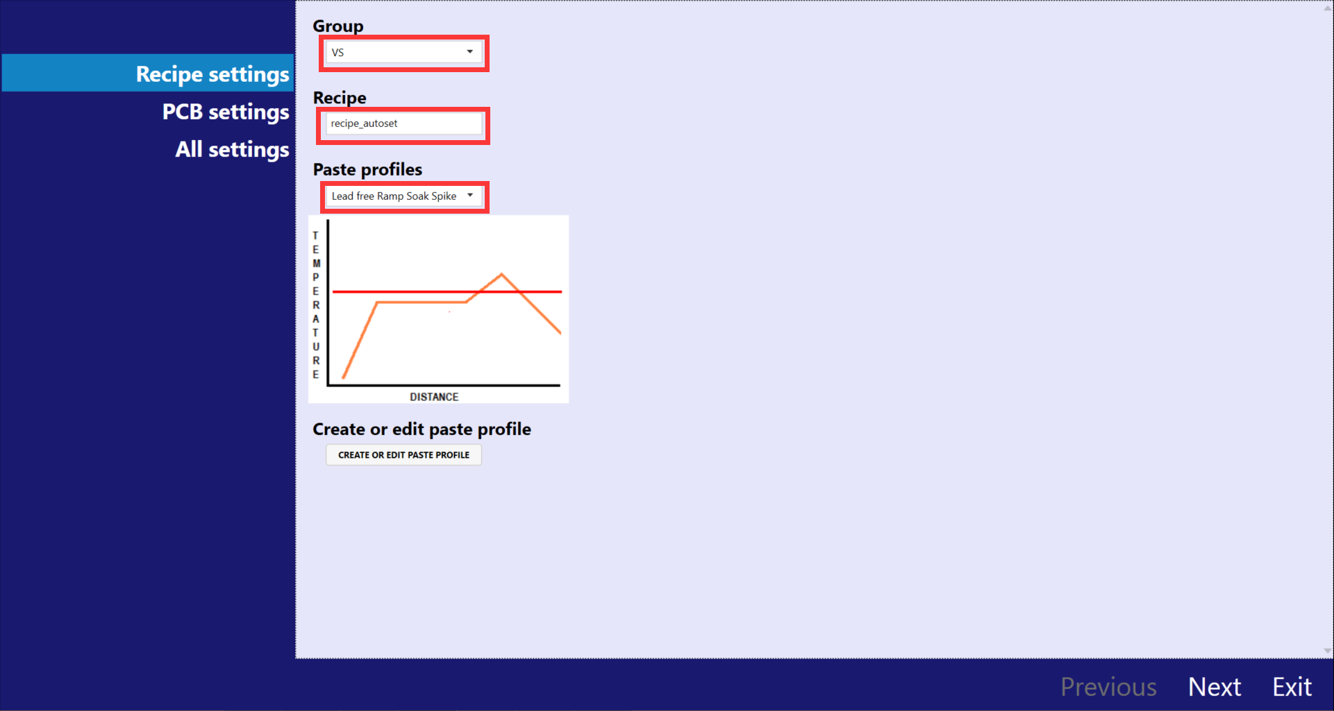
Select recipe group and paste profile and input recipe name. If you want to create or edit paste profile, click the “CREATE OR EDIT PASTE PROFILE” button.
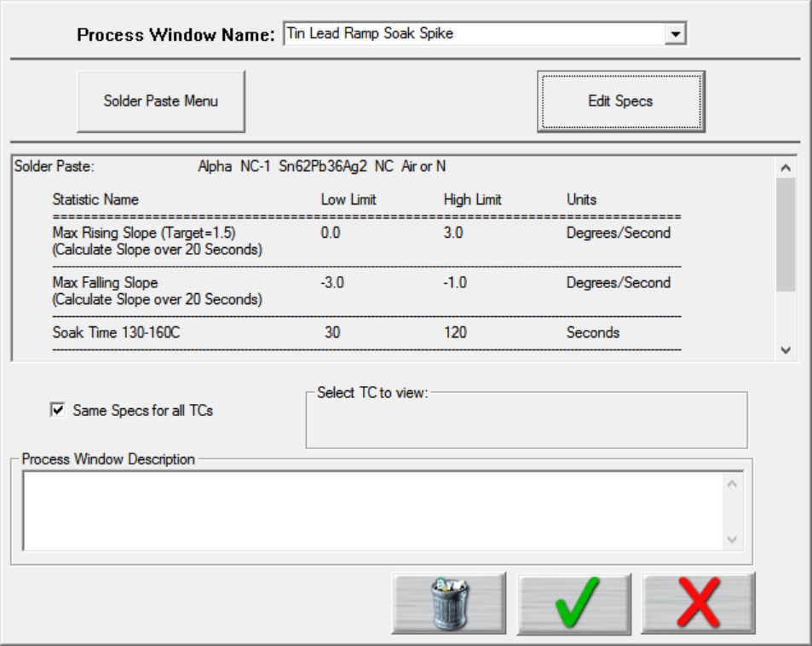
In the “Process Window Name:” type in what you want to call the new Process Window. Type your descriptive name and press the “Enter” key, the following popup box will appear. Select “Yes” to add this new process to the list of Process Window.
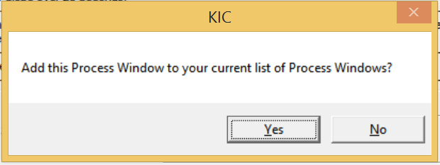
Then you can click “Solder Paste Menu” button to select the solder paste, or you can click “Edit Specs” to edit the parameters of the selected solder paste.

  - PCB settings

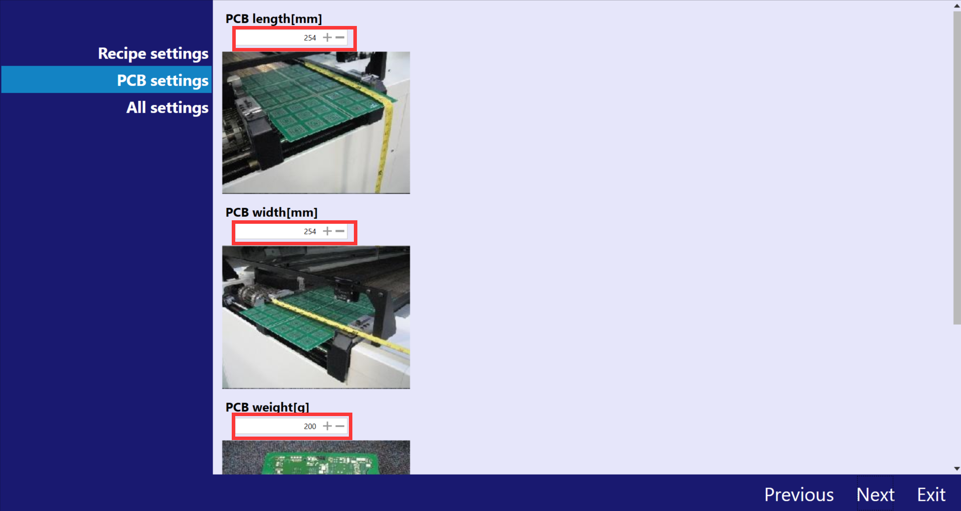
Input the actual length, width and weight of PCB, leave the “Conveyor min value” and “Conveyor max value” to the default value. The upper limit of length, width and weight is 889mm (about 35 inch), 559mm (about 22 inch) and 1500g separately.

  - Run Autoset

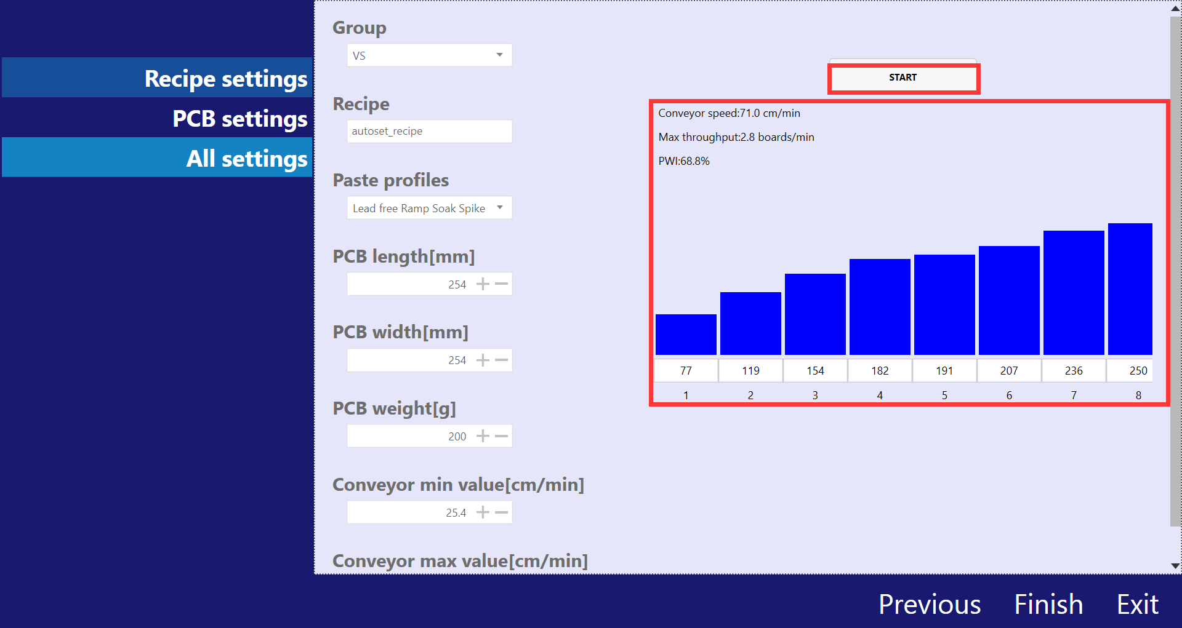
Click the “Start” button. After tens of seconds, the predicted results appear, which includes heater setpoints, conveyor speed, max throughput and PWI.

  - Save recipe

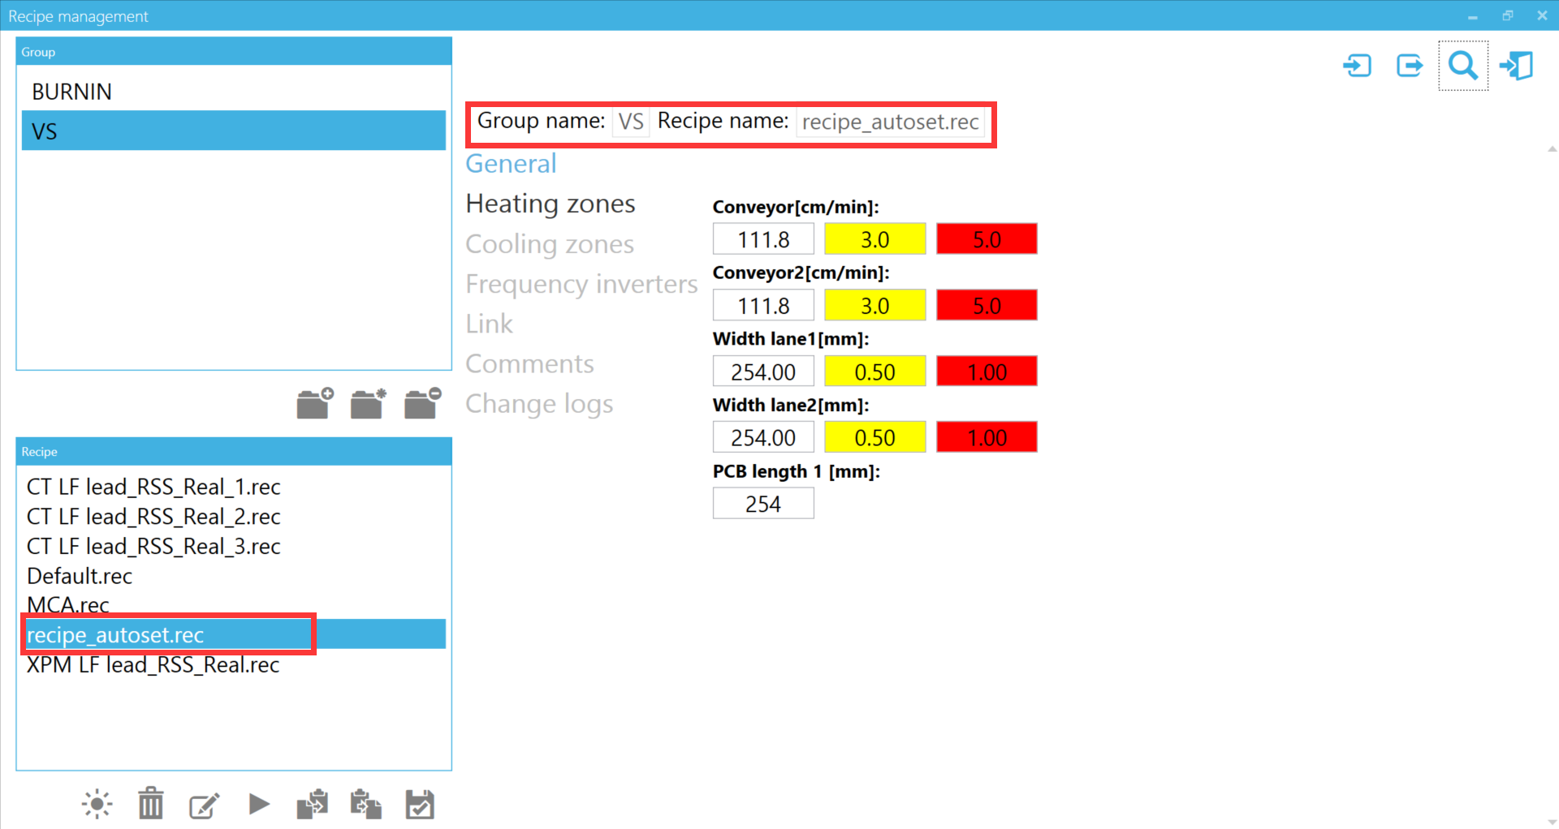
Click the “Finish” button, the result will be saved as a recipe automatically. You can view or edit it in the recipe management function.

  - Test and edit the new recipe
Perform a thorough test of the recipe before releasing it for production.

- Frequently asked questions
What does Autoset do?
Autoset suggested heater and conveyor setpoints that are intended to optimize a thermal profile for a particular board.

How does Autoset work?
Autoset takes the board dimensions (which are entered by operator) and the paste profile (which selected by operator), then searches a library of profile to calculate setpoints of heater and conveyor and to generate a Centurion recipe.

Does Autoset set all the recipe parameters?
No. Autoset just generates heater setpoints, conveyor speed and conveyor width. Other recipe parameters such as cooling temperature, the cell fan frequency and the type of atmosphere are not determined by Autoset, which should be reviewed before using the recipe.

What are the benefits of Autoset?
Autoset gives the end user, a library of profiles developed by an experienced process engineer. Autoset will limit but not eliminate the time required to develop functional recipes. Less time developing recipes means more time running product.

Why should I use Autoset If I am an experienced process technician?
Autoset saves your time by quickly predicting an optimized recipe. The technician can use the recipe as is or modify and use it.

How accurate will the Autoset predictions be?
The accuracy depends the Process Window selected, the board dimensions and the board components. The closer the board dimensions and Process Window selected are to those in the database, the more accurate the prediction will be. More complex boards with large BGA’s will likely require some tweaking of the predicted setpoints.

I use ECD will it work with ECD?
Autoset will work with any third party thermal profiler.

I use KIC will it work with KIC?
Autoset will work with any third party thermal profiler.

How or why does it work differently with KIC verses other profilers?
Boards profiled with KIC can be manually added to the Autoset database. This enlarges and customizes the database making future predictions more accurate.

What differences will I encounter on ovens where the line voltage frequency is not 50Hz?
The Autoset database was developed with the cell fans frequency 50Hz, if Nitrogen type, the cell fan frequency of the first zone is 20Hz. If the cell fans frequency of oven is different, you might require more adjustment of the heater setpoints.

Are there any additional considerations for dual lane application?
On production runs with two lanes of product it is unsure how consistently each lane will run. Treat this situation as a single lane when using Autoset. Thoroughly test the recipe with both lanes running and adjust the setpoints until the desired results are achived.

Can I use one Process Window with more than one recipe?
Yes. Any Process Window can be used with any number of different recipes. You may sometimes need to have multiple Process Windows for each paste in the need to accommodate thermal sensitive board components.

Why do I run Autoset failed?
If you get fail information when running Autoset, the probable reason is that your board dimensions exceed the upper limit in current database.

